Component #1: [Condition] Is EOF Or SOF
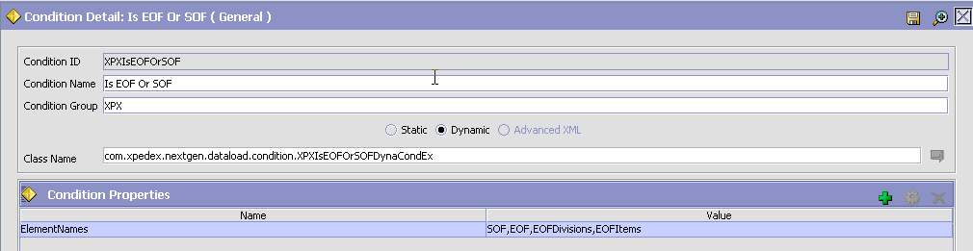
ConditionID: XPXIsEOFOrSOF
Condition Name: Is EOF Or SOF
Condition Group: XPX
Class Name: com.xpedex.nextgen.dataload.condition.XPXIsEOFOrSOFDynaCondEx
Save the above data and enter the following:
Condition Properties:
ElementNames | SOF,EOF

Component #2: [Service- Custom API] ManageFeedsService
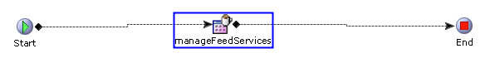
Properties:API:
General Tab:
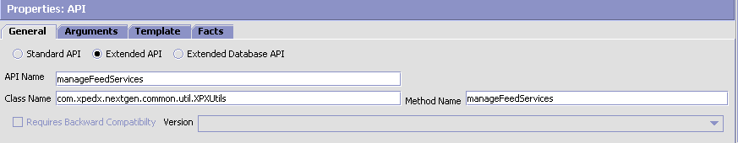
Extended API
API Name: manageFeedServices
Class Name: com.xpedx.nextgen.common.util.XPXUtils
Method Name: manageFeedServices
Arguments Tab:
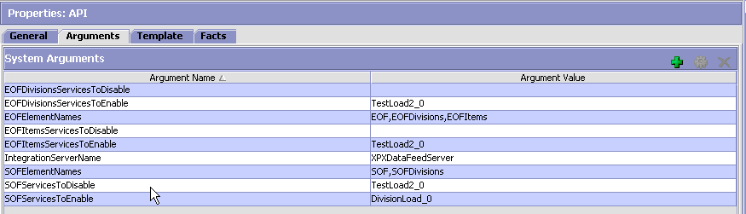
Attribute Name | Attribute Value
IntegrationServerName | XPXDataFeedServer
EOFElementNames | EOF,EOFDivisions,….<Sterling_EOF_Message_Root>
SOFElementNames | SOF
SOFServicesToEnable | DivisionLoad_0 (On SOF List of sub-services to resume.)
SOFServicesToDisable | TestLoad2_0 (On SOF List of sub-services to suspend.)
EOFDivisionsServicesToEnable | TestLoad2_0 (On EOF message on DivisionFeedQ List of sub-services to resume.)
EOFDivisionsServicesToDisable | (On EOF message on DivisionFeedQ List of sub-services to suspend.)
Note:
- Above two lines will be repeated for each Feed.
- SOFElementNames, EOFElementNames, SOFServicesToEnable, SOFServicesToDisable, <Sterling_EOF_Message_Root>ServicesToEnable,<Sterling_EOF_Message_Root>ServicesToDisable can have values separated with ‘,’.
- For each Feed configure following arguments:
- Argument Key as <Sterling_EOF_Message_Root>ServicesToEnable and values as List of comma separated Sub-service names of the other feeds which are required to be resumed.
- Argument Key as <Sterling_EOF_Message_Root>ServicesToDisable and values as List of comma separated Sub-service names of the other feeds which are required to be suspended.
- Argument “IntegrationServerName” should be only one, and i.e., Integration server name to which all these Feed services are configured

Component #3: A-Sync Data Load Service Configuration:
Old Service Config:
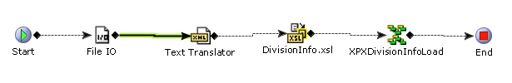
New service should be changed like this: Replace File IO and Text Translator components with Weblogic JMS and an Is EOF/SOF condition, on false of the condition process the message.
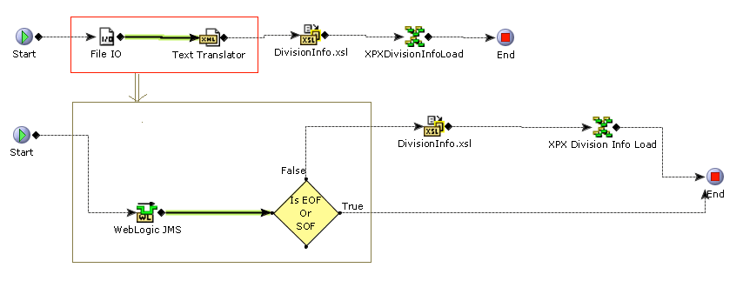

Weblogic JMS:
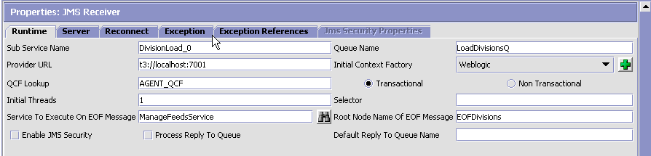
Properties:
Sub Service Name: DivisionLoad_0
Provider URL: t3://localhost:7001
QCF Lookup: AGENT_QCF
Initial Threads: 1
Service To Execute On EOF Message: ManageFeedsService
Queue Name: LoadDivisionsQ
Initial Context Factory: Weblogic [Select]
Root Node Name of EOF Message: EOFDivisions
Server Tab:
Server Name: XPEDXDataFeedServer [Create/Select]
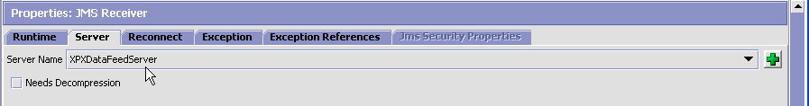
Reconnect Tab:
Maximum Time between reconnects (min): 1 (minimum 1)
Exception Tab:
Alert Type: XPEDXDataFeedException
Alert Queue Name: DEFAULT
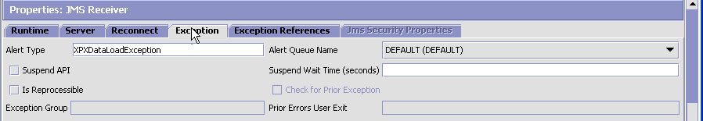
Exception References Tab:
NONE
Condition (Is EOF Or SOF):
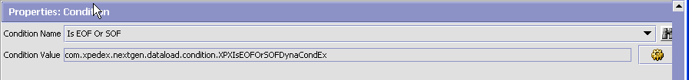
Search and Select Is EOF Or SOF Condition and select.

Info: Sequencing Data Feed Story:
Feed Sequence: Divisions→Items→ItemDivision
Sample Message Load Sequences:
Divisions:
Queue: DivisionFeedQ
MSG1: <SOF />
[Service Checks if incoming MSG is a Start Of Feed by checking it Root element=SOF, and invokes the ManageFeedsService, which in turn processes SOF and Suspends all the Depended Services, by taking IntegrationServerName andService names SOFServicesToEnable and SOFServicesToDisable. ]
MSG2:
<Divisions YantraMessageGroupID="DIVLOAD1.csv_20100722123414348428">
<Division AccessBranchNo="IQ" AddressLine1="DALLAS CONSIGNMENT"
AddressLine2="2424 N. WESTMORELAND RD."
AddressLine3="DALLAS, TX 75222"
BranchName="XPEDX DALLAS/FW" CompanyCode="MM"
CountryCode="USD" DivisionPhone="02146315047" EnvironmentId="AP"
JDECode="266" NationalAccount="" NoOfDays="" PricingWareHouse=""
ProcessCode="A" Status="" TransferCircle=""
TransferCircleName="" WareHouseName="XPEDX, DALLAS/FW CONSIGNMENT"/>
</Divisions>
[Service translates the incoming the message and processes using XPXDivisionInfoService]
MSG3: <EOF YantraMessageGroupID="Required attribute by yantra for an EOF message"/>
[ManageFeedsService will get the input XML as follows:
<EOFDivisions YantraMessageGroupID="Required attribute by yantra for an EOF message"/>
This service will make an API call modifyServer by RESUMEing all services set in EOFDivisionsServicesToEnable property, And SUSPENDing all services set in EOFDivisionsServicesToDisable property. Here say the next feed is Item Load, then that service will be RESUMEd.]
Chain continues like between Dependent Services…..

Please see below the step by step process:
The integration server name will be read from the configurator properties as below:
String strServerName = _properties.getProperty("IntegrationServerName");

Then, the service getServerList will be invoked with the following input document:
Document docInput : <Servers Type=’IntegrationAgentServer’/>

The server Id will be extracted from the output document of getServerList call as below:

Document response = api.invoke(env, "getServerList", docInput);

String strServerID = SCXmlUtil.getXpathAttribute(response.getDocumentElement(), "./Server[@Name='" + strServerName ` "']/@Id");

ServiceToEnable will be read as below where strRoot is the root tag of the incoming XML (EPF/SOF):
String strServicesToEnable = _properties.getProperty(strRoot + "ServicesToEnable");

ServiceToDisable will be read as below where strRoot is the root tag of the incoming XML (EPF/SOF):
String strServicesToDisable = _properties.getProperty(strRoot + "ServicesToDisable");

Next step is to invoke the ‘modifyServer’ API with the below input document:
Document docInput:
<Server Id=’strServerID’>
<Service Action=’Resume’ Name=’strServicesToEnable’/>
<Service Action=’Suspend’ Name=’strServiceToDisable’/>
<Server/>

api.invoke(env, "modifyServer", docInput);

CENT Tool integration changes
The respective service checks if the incoming message is a Start Of Feed (SOF) or End Of File (EOF) by checking its root element.
- EOF validation will be done by the queue component.
- SOF validation is done by the condition component ‘Is EOF Or SOF’.

EOF validation:
In case of an EOF, the service ‘ManageFeedsService’ will be triggered by the queue.
PFB the configuration.
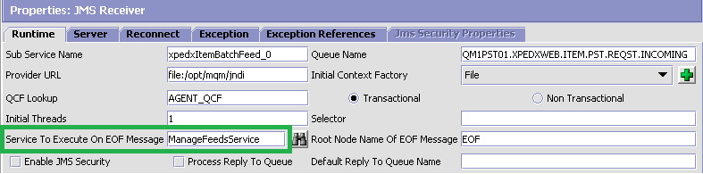

ManageFeedsService will in turn process the EOF message (XPXUtils.processEOFOrSOFMessage() method) and suspends all the depended services based on the IntegrationServerName andService names SOFServicesToEnable and SOFServicesToDisable.
Modifications done for CENT tool integration:
Before processing the EOF/SOF messages, the incoming message will be validated by the XPXUtils.validateIncomingMessage() method to see if it is an EOF or SOF message.

This method will also find out which Feed is coming in by getting the value of the attribute FeedName of the incoming XML. PFB the code snippet doing the same:
String feedName = inXML.getDocumentElement().getAttribute("FeedName");

Based on the above validation, prepareEOFOrSOFMsgObject() method will add an entry will be added to the XPX_ERROR_NOTIFICATION table denoting if it’s an EOF or SOF message.

The Stack Trace column of the above table will be fed with messages respective to EOF & SOF as below:
For EOF: This is an EOF message of the <feedName>
For SOF: This is an SOF of the <feedName>

SOF validation:

In this case, the ‘IsSOF’ condition class XPXIsEOFOrSOFDynaCondEx.java will validate if the root element is ‘SOF’.
If yes, it invokes the ManageFeedsService, which in turn triggers the above mentioned processes.

Service Name: ManageFeedsService
Service Group Name: XPXDataLoad
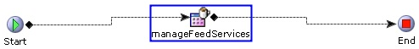
Properties: API
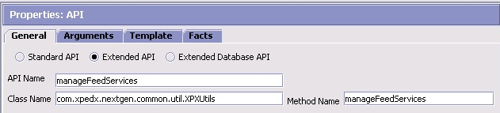

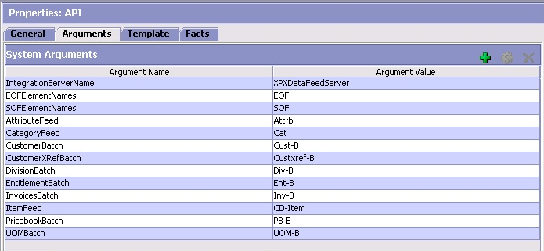

Attribute Name | Attribute Value
AttributeFeed | Attrb
CategoryFeed | Cat
CustomerBatch | Cust-B
CustomerXRefBatch | Custxref-B
DivisionBatch | Div-B
EntitlementBatch | Ent-B
InvoicesBatch | Inv-B
ItemFeed | CD-Item
PricebookBatch | PB-B
UOMBatch | UOM-B

